


GUIDANCE FOR ALL PRSB STANDARDS

August 2023
[DATE]

Document Management

Revision History
Version | Date | Summary of Changes
0.1 | 25/08/2021 | First draft as general “Guidance for all PRSB standards”
1.0 | 02/02/2022 | First version after incorporating reviewer comments
1.1 | 25/05/2022 | Updated for changes to how provenance data is held in PRSB information models
1.2 | 31/01/2023 | Minor updates
1.3 | 27/03/2023 | Minor update to Section 1.1
1.4 | 15/08/2023 | Update to include new version numbering scheme
1.5 | 01/07/2024 | NHS Health Check specific guidance added

Reviewers
Reviewer name | Title / Responsibility | Date | Version
Sandip Kaur | Architect | Sep-2021 | 0.1
Charlie McCay | Technical Adviser | Sep-2021 | 0.1
Lorraine Foley | CEO | Sep-2021 | 0.1
Annette Gilmore | PRSB conformance lead analyst | Sep-2021 | 0.1

Approved by
Name | Date | Version
PRSB Task and Finish Group | May-2022 | 1.1

Glossary of Terms
Term / Abbreviation | What it stands for
dm+d | Dictionary of medicines and devices
EPR | Electronic Patient Record
FHIR | Fast Healthcare Interoperability Resources
GP | General Practitioner
HL7 | Health Level 7
Metadata | A set of data that describes and gives information about other data
NICE | The National Institute for Health and Care Excellence
NHS | National Health Service
NHSDD | NHS Data Dictionary
NHSE/ NHSEI | NHS England/ now NHS England Improvement
NRLS | National Record Locator Service
ODS | Organisation Data Service
PDS | Personal Demographic Service
PRSB | Professional Record Standards Body
DAPB / DCB / SCCI | Data Alliance Partnership Board, formerly Data Co-ordination Board and Standardisation Committee for Care Information. Acts on behalf of SoS health to approve health and care data and information standards
SNOMED-CT | Systematized Nomenclature of Medicine - Clinical Terms

Contents
1 Introduction 4
1.1 Purpose of this document 5
1.2 Audience 5
2 General Guidance 5
2.1 Structure of the PRSB standards explained 5
2.2 Version Numbering 8
2.3 Dependencies 8
2.4 Risk Mitigation 8
2.5 Information Governance 8
2.6 Data Quality 9
2.7 Context of the information 9
2.8 Time stamp and audit trail 10
2.9 Links to other records and documents 10
2.10 Use of terms 10
2.11 Coding 10
2.12 Accessibility 11
3 NHS Health Check Standard Guidance 11
3.1 Standard Definition Scope 11

Introduction

Purpose of this document
This document provides general guidance to support the implementation and use of all PRSB standards.
Specific implementation guidance for specific standards at section and element level is available as part of the information model for that standard.
In addition, each standard will have a safety case and hazard log developed and approved in accordance with the DCB0129: Clinical Risk Management standard. This guidance should be used in conjunction with section 2.3 Risk Mitigation.

Audience
This guidance is intended for anyone implementing and using PRSB standards. This will include health and social care professionals, IT system suppliers, developers, and implementors.

General Guidance

Structure of the PRSB standards explained
An information standard is organised into sections made up of several data (information) elements, with record entries and clusters (subsections) to support repeated sets of information and grouping of related items.
The set of rules and instructions governing the type of information expected within a section, cluster, record entry and element and how it is communicated is defined in the information model under the titles of Description, Cardinality, Conformance and Valuesets.
The PRSB information model structure and rules are explained in Table 1 and the annotated example below.

Information Components | Model Description
Section | A section groups together all the information related to a specific topic e.g. ‘Medications and medical devices’ and ‘Person demographics’.  It is the highest level to logically group data elements that may be independent or related. For example:  - ‘Legal information’ includes a set of independent elements or information items, grouped in a logical section.  - ‘Medications and medical devices’ includes sets of related elements with dependencies between the elements.
Record entry | A record entry within a section is typically used where a set of information is repeated for a particular item, and there can be multiple items. For example, for each medication there is a set of information associated with that medication. Other examples are allergies or adverse reactions and procedures.  A record entry has contextual information associated with it. The data model for the context information is determined by the information type of the record entry. There are two information types used: “Record” and “Event.Record”.  For “Record” entries, the provenance data includes the person recording the data, and the time it was recorded. For “Event.Record” entries, details of the performer of the event, the location, and the time the event happened are also included in the provenance data.
Cluster | This is a set of elements put together as a group and which relate to each other; e.g. medication course details cluster which is the set of elements describing the course of the medication.
Element | The data item.  An element can appear in one or more sections e.g. name, date.
Information model rules and instructions | Explanations
Description | This is the description of the section, record entry, cluster or element. For an element, it describes the information that the element should contain in as plain English as possible.
Cardinality | Each section, record entry, cluster and element will have a statement of cardinality. This clarifies how many entries can be made i.e. zero, one or many entries. The number of records expected and allowed are displayed as:  0……* = zero to many record entries are allowed  0……1 = zero to one record entry is allowed  1……1 = one record is expected  1……* = one to many records are expected  For example, the ‘Medications and medical devices’ section may have zero to many medication item records in it and is displayed as 0…… *.
Conformance | Conformance defines what information is ‘mandatory’, ‘required’ or ‘optional’ and applies to sections, record entries, clusters and elements.  The IT system must be developed to handle all the information elements that are defined in the Standard but not all the information is required for every individual record or information transfer.  The following set of rules apply to enable implementers to cater for the end users (senders and receivers) requirements:  - Mandatory – the information must be included  - Required – if it exists, the information must be included  - Optional – a local decision is made as to whether the information is included  These rules apply at all levels and give the flexibility to allow local clinical or professional decisions on some information that is included, while being clear on what is important information to include.  For example, a person subject to a referral may have many assessments, but not all of these will be relevant to the referral. The conformance can be used to allow just relevant assessments to be included.  Assessment Section – Required – i.e. its important information you must include if you have it.  Record entry level – Optional – allows a local decision on what assessments are included, so only relevant ones are included based on clinical or professional needs.  Assessment elements – Conformance set on the normal basis of which elements for an assessment are mandatory, required or optional.  NB: It is permitted to upgrade a conformance rule but not to down grade one. For instance, a section that is classed as optional in the standard can be upgraded to required or mandatory in local implementations. However, one that is classed mandatory or required cannot be downgraded to required or optional.
Valuesets | Valuesets describe precisely how the information is recorded in the system and communicated between systems. This is required for interoperability (for information to flow between one IT system and another).  The information can be text, multi-media or in a coded format. If coded it can be constrained to SNOMED CT and specific SNOMED CT reference sets, NHS Data Dictionary values or other code sets.
Table 1: PRSB information standard data structure
In the annotated example shown below for Allergies:
- The standard has a section for ‘Allergies and adverse reactions’, it’s conformance is ‘mandatory’ and the cardinality is ‘1 only’ (or 1...1) i.e. there must be just one allergies section
- It has a record entry to allow for multiple allergies, which is also ‘mandatory’ so with a cardinality of 1 to many (or 1...*). The record entry contains a set of elements, i.e. the set of information for each allergy and there must be at least 1 record entry.
- The record entry also includes a cluster (reaction details cluster), which groups the reaction details together.
- Each element has a description, conformance, cardinality and valueset. e.g. Causative agent, which is mandatory with a cardinality of 1 only (or 1…1) and a valueset with two options, coded value with a constrained set of SNOMED codes (including an option for “No known allergy”) or free text if coded values are not available. Other elements are required in this example. i.e. the set of information for each allergy or adverse reaction must have a causative agent, and where available should have the other information such as reaction details, substance, severity etc.
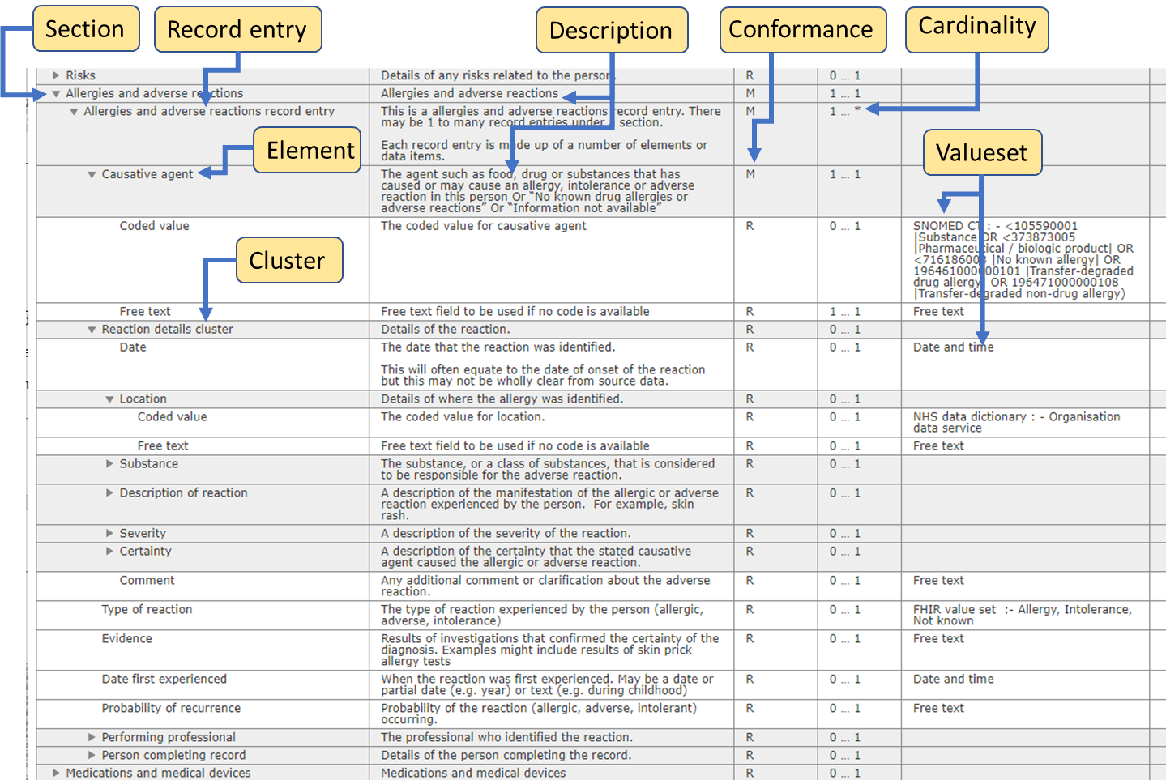

Version Numbering
PRSB standards published with the detailed implementation guidance in the information model use a 3-segment version number, e.g., V3.01.02, while older standards published before the detailed implementation guidance was put into the information model retain the previous 2-segment version number, e.g., V2.02 until their next maintenance release or revision.
2-segment version numbers take the form of major version.minor version, e.g., V2.02 where the information model is major version 2 and minor version 01.
3-segment version numbers use the format Va.bb.cc where:
- a - is the major version number of the information model, incremented on significant revisions or enhancement of the information model
- bb – is the minor version number of the information model, incremented on minor updates such as changes or issue resolutions
- cc – is the implementation guidance version number, incremented whenever the implementation guidance is updated, which can be with or independent from an information model update. At a major revision of the information model this will restart at version 01.

Dependencies
The implementation of PRSB information standards is often dependent on the following:
- The national and local Information Governance frameworks which will determine information access and sharing controls and legitimate relationships between health and care provider organisations.

- Technical messaging standards e.g., FHIR profiles (to support the transfer of information between systems).

- The availability of other sources to access some of the person’s care information such as the national record locator service (NRLS), GP records and shared care records.

Risk Mitigation
We recommend system suppliers and local implementers apply further risk mitigations when implementing PRSB standards by addressing the risks that have been flagged in the clinical safety case report and hazard log for each standard. Suppliers and implementors should aim to reduce the risk scores to 2, or better, when carrying out clinical risk assessments and developing safety cases for their implementations with respect to DCB0129 and DCB0160.

Information Governance
Sound principles of information governance and respecting the privacy of people and their information is paramount. NHS England has published a national Information Governance framework which needs to be considered when planning implementation.
Local agreements should be drawn up between organisations to define information requirements for communication.

Data Quality
Data quality and accuracy of coded data entry should be managed in local ‘source’ systems to ensure that information shared with people and professionals through other systems is dependent on the source data quality.

Context of the information
It is vital for use of the data that all contextual information is maintained and should not be lost on exchange or import of information. For example, if a frailty assessment was undertaken at the care home 2 days before the individual was admitted to hospital it is important that the full context of the information is known (where and when the assessment was done and by whom).

The principle, for PRSB standards, is that for clinical safety and efficacy of communications, the following key contextual data should be shared where specified by the “information type” of the data item in any PRSB standard.:
- Performing Professional – is the person who performed the activity for example conducted the procedure, assessment etc. It has various attributes that are expected to be completed, name, role, specialty, organisation of the professional. If the professional is not known but the organisation and specialty are known they should be included as contextual information. In some situations, the action or event may be performed by the patient or a device. In these situations, a Performing Person or Performing Device may be recorded. Alternatively a more generic “Performer” may be specified with the same content model as “Performing Professional”.

- Location – the place in which the activity took place e.g., observations were made.

- Date - the date on which the activity took place e.g., the assessment was performed. In some instances, this would be start and end dates.

- Author - is the person, device or application that recorded the information and has various attributes; name, role, speciality and organisation and the date the record was completed. This is expected to be automated and linked to audit trail (see section 3.8).
Note that although both ‘Performing professional’ and ‘Author' contain the element ‘speciality’ it is recognised that this only applies to some professionals so only needs to be included where relevant.
The principle applied in the information model is that where it is important (from a professional perspective) to know who undertook the activity and who recorded the activity, an information type of “Event.Record” or “Record” will be included in the model. For every item of information shared it is important that an audit trail is recorded (even if not explicitly stated in the information model). This is set out below.
The provenance information model is published on the PRSB website Provenance data – PRSB (theprsb.org)

Time stamp and audit trail
It is important that an audit trail is recorded for every item of information recorded or shared (even if not explicitly stated in the information model).
Each record entry will need to be time stamped from the source system with date and time recorded and the identity of the person making the record. This needs to be viewable in the records themselves where appropriate and via a full audit trail which may be viewable by the end user to enhance transparency.

Links to other records and documents
The person may have multiple detailed records or documents held on local systems, e.g. there may be a mental health record for a person at a particular trust or shared care records such as an end of life care plan. PRSB record standards do not define all these possible links. It is expected that the local areas will define the requirements for accessing other records or documents, and where applicable and provide access through the shared care record for authorised professionals.

Use of terms
The term ‘role’ has been consistently used rather than ‘designation’ throughout PRSB standards to apply to the role the professional had in an activity. It is the term used in the NHS data dictionary.
The term ‘organisational role’ means the role the professional has in their employer organisation.
Some clusters such as referrer details have elements for one or more of specialty, team, service and department. This is to allow for all situations across health and care where different terms are required. Where possible specialty and service should be used and coded as detailed in the value set for the element.

Coding
The Personalised Health and Care 2020 framework for action
(https://www.gov.uk/government/publications/personalised-health-and-care-2020) recommends the use of SNOMED CT and the dictionary of medicines and devices (dm+d). Local decisions need to be made about when these codes are to be used, depending on local system functionality and plans. The current ambition is for SNOMED CT and dm+d to be the primary clinical coding schemes in use in the NHS.

Accessibility
The design of user interfaces for health and care record systems should follow guidance for specific PRSB standards and should comply with the NHS England Accessible Information Standard (https://www.england.nhs.uk/ourwork/accessibleinfo/). This sets out the rules for accessible patient information in patient literature and clinical systems.

NHS Health Check Standard Guidance

Standard Definition Scope
Please note that the standard does not define the whole of a clinical record - but part of the record defined by the scope of the standard. The scope of the standard can be found in the final report.

